Inscryption multiplayer

The process

Contents

Inscryption 3

Game explanation 3

Research 4

‘Engine’ 4

Requirements: 4

Design 5

Multiplayer 5

MVVM 5

My implementation 5

Networking 5

Visuals 5

Reference 6

Table of abbreviation 6

References 6

Feature list 6

# Inscryption

### Game explanation

Inscryption is a 1v1 turn based card game. To win you need to damage the opponent’s side of the board (no cards in opposing spot). On the side of the board is a scale which keeps track of the damage done. Once the scale is fully tipped to the opponents side you win and when it is fully tipped to your side you lose. To damage your opponent, you need to play cards.

In the first part of the game these cards are animal themed. This is the game I’m going to recreate at first. I would like all the other functionality to be in the game as well but that’s a could on the MuSCoW scale. Every animal card has different health, damage and cost and special effects which are called ‘sigils’ which I will explain a little later.

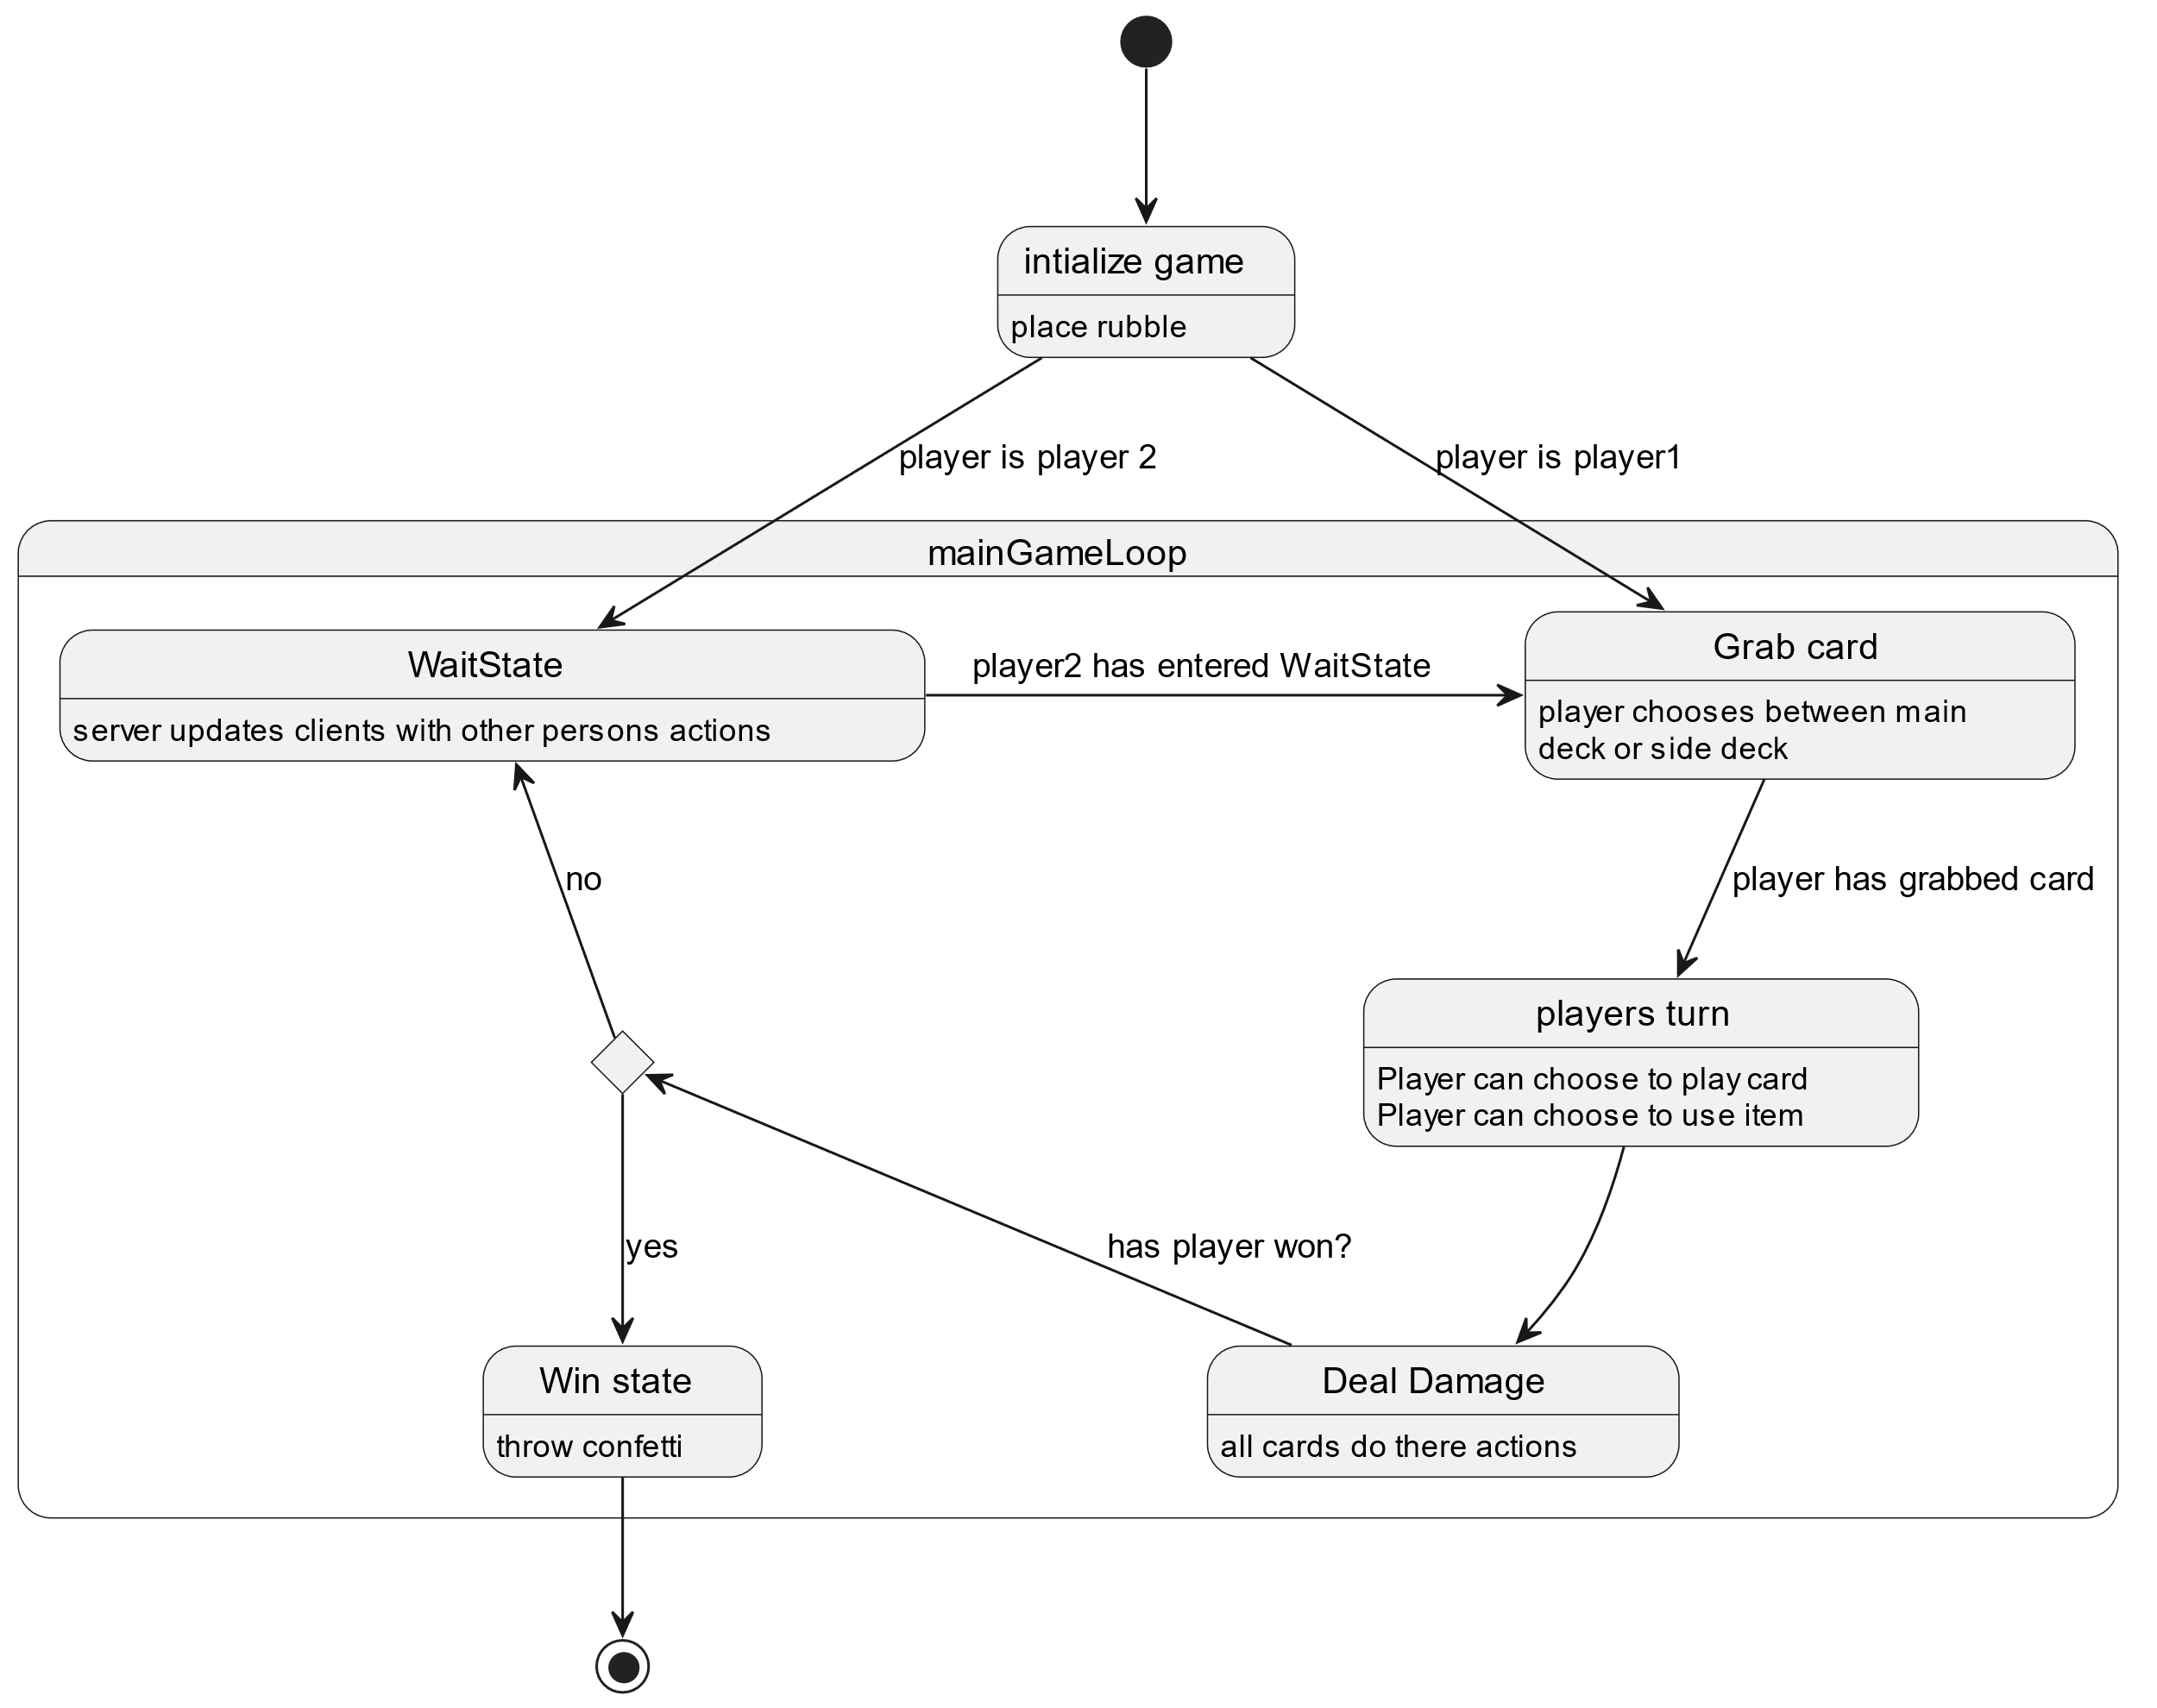In act 1(the version I’m recreating) you have 2 decks. 1 which are your attacking animals and 1 which are your sacrificial animals. The sacrificial deck contains squirlsf which has 0 cost but is very weak with 0 damage and 1 health. You can use this card to block incoming damage or play it to sacrifice for a better card which you need to have in your hand. The other deck is filled with all kinds of different animals with different stats and effects, but these usually have a cost. The cost of these cards is blood which means you need to sacrifice another card to play this one. On the right you can see a ‘River snapper’ which is a very tanky card which is able to block a lot of damage because of its relatively high health stat. as you can see it has 2 blood marks on the right under its name which means that he needs 2 other animals sacrificed on the board for this one to be played.

#### Game flow

I will describe the game flow for my game:

1. At the start of the players turn you grab a card from 1 of the 2 decks on the side of the board.
2. Player turn:  
   you can play as many cards as you want  
   you can use items which are on the side of the board  
   or do absolutely nothing.
3. At the end of a players turn all cards do damage from left to right.

If you have not tipped the scale fully to your opponent’s side, it’s their turn.

# Research

## ‘Engine’

Before I started creating the game, I wanted to make sure that I wouldn’t make a big mistake in choosing to make the game in WPF compared to a game engine which in my case would have been GODOT. To make correctly do this research I started with a list of requirements of what I wanted for the game.

### Requirements:

* Visuals
  + 2d
  + Animations
  + Simple
* Power efficient
  + /low resource use

After this I created a pro and cons list for both WPF and GODOT

|  |  |  |  |
| --- | --- | --- | --- |
| GODOT | | WPF | |
| Pros | Cons | Pros | Cons |
| Less backend development needed. | Very high resource usage = not power efficient. | Low resource usage. | Not a game engine, expect lots of backend work. |

The List didn’t seem sufficient enough because I couldn’t come up with a comprehensive list of pros and cons so I resorted to a Pugh matrix

|  |  |  |  |
| --- | --- | --- | --- |
| Feature | Weight | WPF | GODOT |
| Graphics fidelity | 1 | 3 | 5 |
| * animation support | 4 | 4 | 4 |
| Resource efficient | 5 | 5 | 2 |
| Ease of development | 2 | 2 | 4 |
| * Audio engine | 2 | 1 | 2 |
| * Controller support | 1 | 2 | 3 |
| * Steam support | 1 | 1 | 2 |
|  |  | 53 | 48 |

The pugh matrix above shows that I’m very focused on low resource efficient especially GPU and CPU because that’s the target group I’m creating the application for. I wanted it to be a multiplayer game which anybody with a simple laptop could play. This meant that I had to expect a graphics card would not even be present hence the resource efficiency score. Graphics fidelity is another interesting topic. I knew it was going to be 2D and should have very little in the way of lighting effects\other graphic effects but I did want it to have animations otherwise it would be to bland and boring. Luckily after some research I found out that WPF had the capability of doing animations on it’s UI elements which was all I needed to know. I knew that when I would create the game in WPF I would have to do a lot more backend work which is where GODOT catches up in score in the matrix. Once I knew WPF had some sort of support for all the things I had in my matrix the outcome of the matrix wasn’t really a concern anymore because I liked the challenge of creating a Game in WPF because it’s not made to do that.

# Design

## Multiplayer

## MVVM

### My implementation

#### Why

## Networking

## Visuals

The visuals are done using view

#### Event based

# Reference

## Table of abbreviation

|  |  |
| --- | --- |
| Terms | Description |
| WPF |  |
| View |  |
| Scene |  |

# References

*What is Windows Presentation Foundation*. (2023, February 16). Retrieved from Microsoft Docs: https://learn.microsoft.com/en-us/dotnet/desktop/wpf/overview/

# Feature list

* Dedicated server
  + Sychronisable scene